# Executive Summary

**CAMPAIGN RESULTS FOR: john**  
Status: Completed  
Created: 2017-06-13T12:19:39+03:00  
Started: 2017-06-13T12:19:00+03:00  
Completed: 2017-06-13T12:21:06+03:00  
**CAMPAIGN DETAILS**  
From: jfrachwan@darbeirut.com  
Subject: Account Security  
Phish URL: http://172.16.151.187  
Redirect URL:   
Attachment(s): []  
Captured Credentials: False  
Stored Passwords: False  
**HIGH LEVEL RESULTS**  
Total Targets: 1  
Opened: 1  
Clicked: 1  
Entered Data: 0

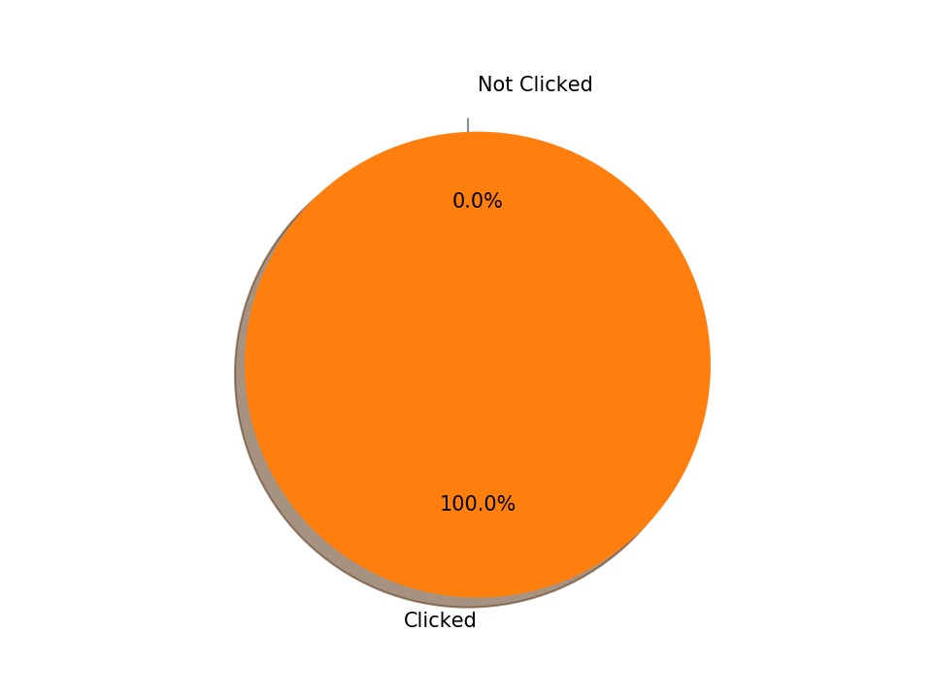

# Summary of Events

The table below summarizes who opened and clicked on emails sent in this campaign.

|  |  |  |  |
| --- | --- | --- | --- |
| **Email Address** | **Open** | **Click** | **Phish** |
| john.rachwan@dar.com | Y | Y | N |

# Detailed Findings

## 

john.rachwan@dar.com

Sent on 2017-06-13 at 12:19:50+03:00

**Email Previews**

|  |
| --- |
| **Time** |
| 2017-06-13 12:20:57+03:00 |

**Email Link Clicked**

|  |  |  |  |  |
| --- | --- | --- | --- | --- |
| **Time** | **IP** | **City** | **Browser** | **Operating System** |
| 2017-06-13 12:21:00+03:00 | 172.16.151.187 | IP address look-up returned None | Chrome 58.0.3029 | Windows 7 |

**Phishgate Data Captured**

|  |  |  |  |  |  |
| --- | --- | --- | --- | --- | --- |
| **Time** | **IP** | **City** | **Browser** | **Operating System** | **Data Captured** |

# Statistics

The following table shows the browsers seen:

|  |  |
| --- | --- |
| **Browser** | **Seen** |
| Chrome 58.0.3029 | 1 |

The following table shows the operating systems seen:

|  |  |
| --- | --- |
| **Operating System** | **Seen** |
| Windows 7 | 1 |

The following table shows the locations seen:

|  |  |
| --- | --- |
| **Location** | **Visits** |

The following table shows the IP addresses captured:

|  |  |
| --- | --- |
| **IP Address** | **Seen** |
| 172.16.151.187 | 1 |